**System’s Flowchart**

***Figure 4:*** *Alumni Management System Flowchart for User’s Side*

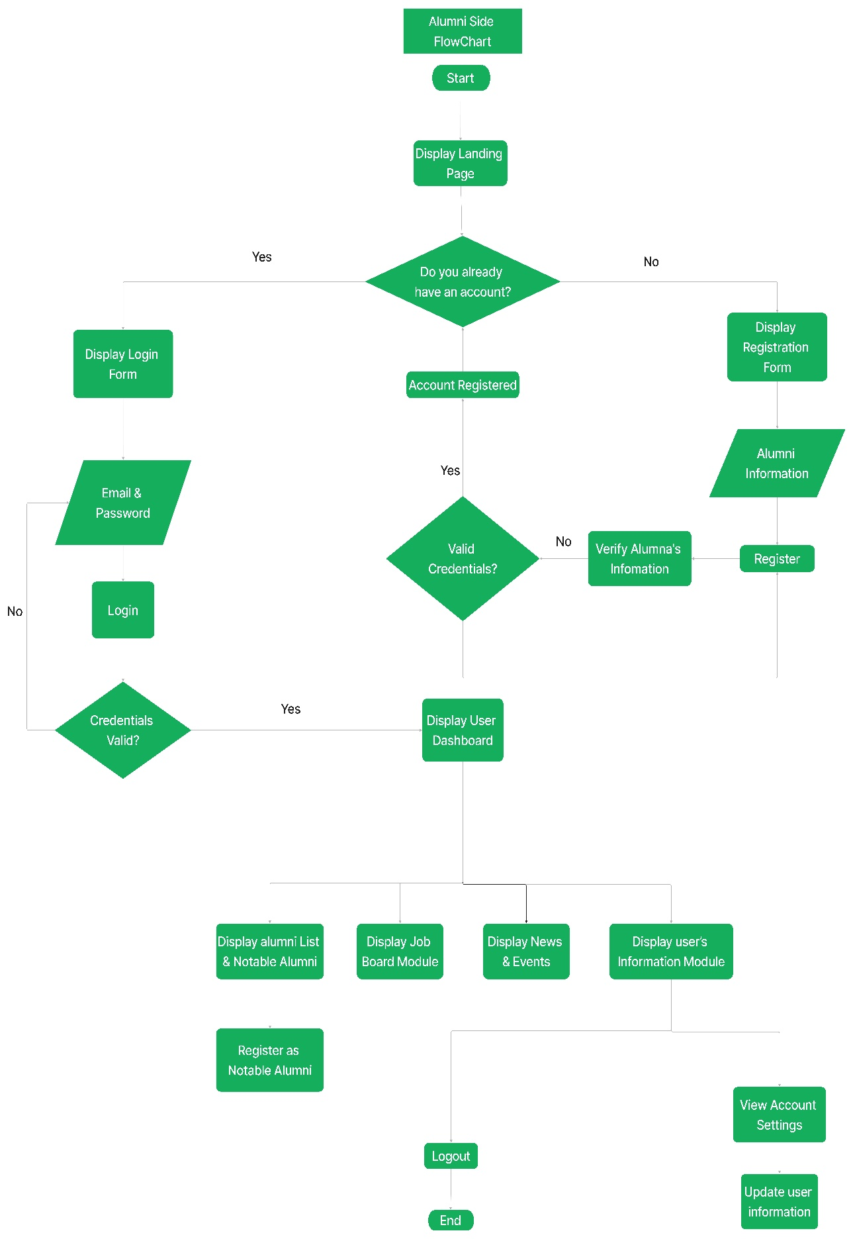

On figure 4, this is what the alumni management system flowchart overview. This shows the user’s accessing the alumni system and its main features. At the start, it is commonly required for the user to be registered at the system, if not, they will be directed to the registration page. In the registration page, it requires the user to input the necessary information the house of alumni requires. Else, the user will continue at the system’s dashboard, where they will be presented the overview of the content of the website. If the user enters the alumni module, they will view the list of alumni and the notable alumni who are recognized for their achievements and contributions. Users may also register as a notable alumnus in this module. The job board module will present alumni where they can check the available jobs posted by the administrators of the house of alumni. Lastly, the user information module, which is basically the user profile where the user may view, change, and update their personal information.

***Figure 5:*** *Alumni Management System Flowchart for Administrator’s Side*

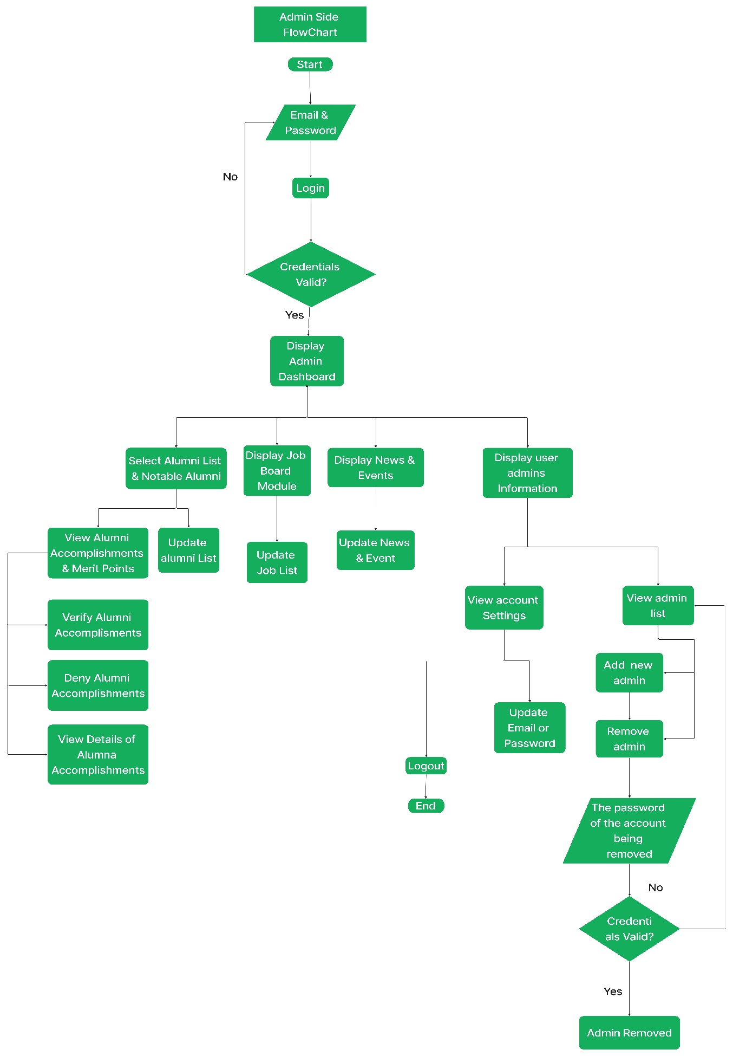

**Project Development**

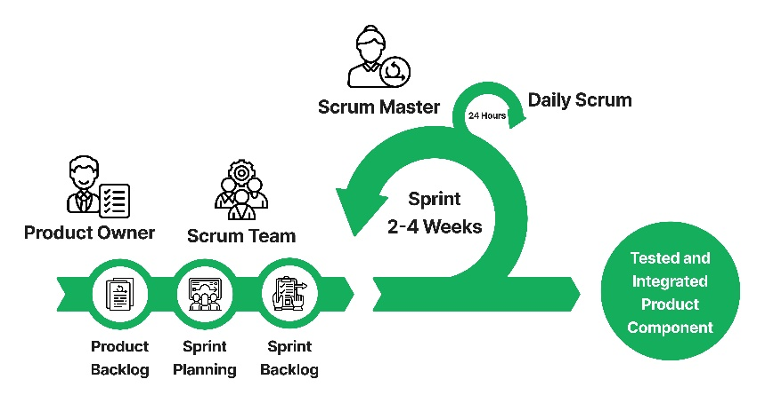

***Figure 3:*** *Agile Scrum Diagram*

Agile method, extensively used in software development and other dynamic industries, can accommodate rapidly changing project needs. Agile Scrum is a popular software development methodology that emphasizes an iterative, incremental approach to continuous improvement. This style requires meticulous sprint preparation, in which teams strategize future work.

Within Agile Scrum, distinct roles and responsibilities are defined. The product owner advocates for the customer's interests and has complete control over the product's outcome. The scrum master serves as a facilitator, organizing daily meetings, improving team chemistry, and increasing productivity. Finally, the team, which normally consists of two to three people, exhibits self-organization and cross-functional competency in analysis, design, programming, testing, and documentation.

Identifying the problems that the developers want to address for their users is the initial stage of enhancing the project. The next step involves gathering data to address each issue that the researcher has identified.

stakeholders, including developers, acquirers, quality assurance and control personnel, and independent evaluators, to specify criteria and assess the quality of target products throughout their lives.

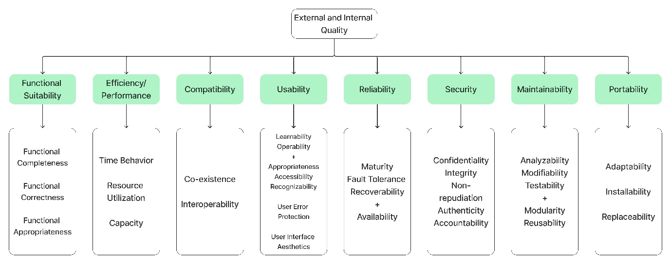

***Figure 12:*** *Categorization of Software Quality*

Quality can be described as the non-inferiority or superiority of anything; a measure of that thing's suitability for its intended purpose (fitness for purpose) while meeting consumer expectations. Simply said, an application's quality is largely determined by how well it functions. The ISO 25010 standard classifies application functionalities and identifies all components of the app that must be verified before it can be launched.

**Functional Suitability** - Developers must ensure the system aligns the client’s criteria, such as the features, functionality, appropriateness, and relevance. The client must be satisfied with the developed system.

**Efficiency/Performance** - Refers to the performance related to the number of resources used. Developers must meet the efficiency when it comes to processing times, resource utilization, and its maximum limits of the system.